6/1/2017



Rev. # 01-06-17

|  |
| --- |
| HP Inc. Channel Services Network  Reseller Guide to the HP Care Pack Services Tool |

NOTICE

Copyright 2005, 2016 HP Development Company, L.P.   
The information contained herein is subject to change without notice. The only warranties for HP products and services are set forth in the express warranty statements accompanying such products and services. Nothing herein should be construed as constituting an additional warranty.

Microsoft and Windows are either trademarks or registered trademarks of Microsoft Corporation in the U.S. and/or other countries.

**HP Inc. Channel Services Network**

Partner Guide to the HP Care Pack Services Tool

Table of contents

Section 1- HP Care Pack Services Tool Overview 3

Section 2 - Minimum System Requirements 4

Section 3 - Starting the System 5

3.1 Launching HP Inc. Channel Services Network 5

3.2 HP Inc. Channel Services Network Login Procedure 6

3.3 Login Error Messages 8

Section 4 - HP Care Pack Services Tool Home Page 9

4.1 Using the HP Care Pack Services Tool Home Page and Navigation Bar 9

Section 5 - HP Care Pack Service Registration 10

Section 6 – Bulk registration 20

6.1 Bulk registration 20

Section 7 - Update Registration 24

Section 8 – Partner Inquiries 27

8.1 Get Registration Report in Excel Format 29

8.2 Get Orders Detail Report in Excel Format 31

8.3 Get the Sales Orders Placed within a Date Range and/or by the P.O. Number 33

8.4 Perform and Inquiry on the Sales Order Number 36

8.5 Find the Registration Information Based on Serial Number 38

8.6 Get the Registration Information Based on Care Pack Serial Number 40

8.7 Get Registrations Expiring in a Date Range Report 41

# Section 1- HP Care Pack Services Tool Overview

The purpose of this guide is to help you better understand the HP Care Pack services tool, also called “ElfPack (Electronic Fixed Care Pack)” within HP Inc. Channel Services Network (HP CSN).

In this increasingly complex world, partners need an easy way to find and select the appropriate services to compliment the sale of hardware. HP Services is driving the way forward with eSelling. The advantages of eSelling are important to HP, HP Services, our partners, and customers. eSelling promotes:

* Ease of doing business
* Ease of selling
* Ease of buying
* Speed of doing business
* Worldwide access to products and service
* Constant availability to information about products and services

Partners discover even more positive attributes as they search out and select services online, including:

* **Representation** — Up-front representation of services included with all applicable products
* **Accuracy** — Accurate service information
* **Consistency** — Consistent location to find services when selecting products on the Web

The HP Care Pack services tool benefits resellers by enhancing the hassle-free HP Care Pack services purchase experience, where everything is taken care of at the time of purchase. There is no need to wait for a packaged service to be delivered; it is available instantly. What is more, the electronic HP Care Pack services tool has a positive environmental impact; eliminating the use of paper goods, storage, and movement of physical stock.

# Section 2 - Minimum System Requirements

HP Inc. Channel Services Network (HP CSN) has been tested and supports Internet Explorer 8.0 and higher on Microsoft Windows platforms as well as other browsers like; Firefox, Chrome and Safari.

Please contact <http://www8.hp.com/us/en/contact-hp/contact.html> if you have any additional questions regarding browser requirements or compatibility issues while using HP CSN.

*Notes: -* You do not have to specify any particular security settings under Internet Options. HP CSN does not make use of any Active-X controls, so the application works fine even at high security settings.

- HP recommends that you delete all Temporary Internet Files regularly and with each new release of HP CSN.

# Section 3 - Starting the System

## Launching HP Inc. Channel Services Network

The HP Care Pack services tool is located within the HP CSN system. To access HP CSN, go to https://h30125.www3.hp.com/hpcsn/?hpp.

*Notes: -* To access the system you must be a member of the HP CSN virtual community.

- If your company is currently an HP Authorized Reseller or Service Provider, but IS NOT a member of the HP CSN community, go to http://www.hp.com/partners/csn to apply for membership.

- If your company is currently an HP Authorized Reseller or Service Provider and IS a member of the HP CSN community, please contact your company’s HP CSN Administrator to add an additional user or location.

## HP Inc. Channel Services Network Login Procedure

* **Step1 -** Enter a valid “user id”.
* **Step 2** - Enter a valid “password”.
* **Step 3** - Click the “Go” button.

**HP Inc. Channel Services Network Login Screen**

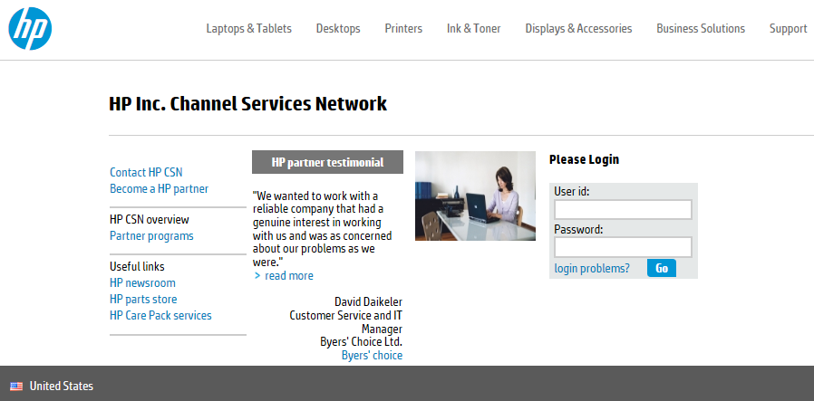

By entering a user id and password and following the login procedure, you are agreeing to the conditions mentioned below.

|  |
| --- |
| PLEASE REVIEW THE TERMS AND CONDITIONS SET FORTH BELOW PRIOR TO GAINING ACCESS TO THE HP NETWORK.  Only those persons authorized by HP may use this network and only for legitimate business purposes. If you are not an authorized user, please disconnect now.  HP has the capability and reserves the right to audit ALL computers and systems, including the file contents of such systems and computers, which are connected to the HP network. This message serves as notification of this fact to you. By completing the login process, you are consenting to such audits. If you object, discontinue the login process now. No further warning or notice will be given.  Additionally, HP reserves the right to inspect, without further notice, all electronic communications, data, and information stored or transmitted on the HP network. HP also reserves the right to add necessary files to and modify the configuration of any connected computer or system to ensure both the security and integrity of the HP network. Misuse of the HP network is prohibited. Misuse includes:   1. Making unauthorized copies of software licensed to HP, or acquiring such; 2. Placing or using unauthorized software on any computer or system on the HP network; 3. Transmitting or forwarding proprietary data for other than legitimate HP business; and 4. Attempting or gaining access to systems or productivity units to which you have not been granted access.   HP will pursue legal remedies against any person who misappropriates or misuses the HP network to the full extent of the law. Any violation of this policy will result in appropriate sanctions, up to and including termination of business relationship. By completing the login process, you are consenting to the above terms of usage for the HP network. If you object, discontinue the login process now. No further warning or notice will be given. |

## Login Error Messages

If you do not enter a valid HP CSN user id or password, the following error message displays:

ERROR: User is not registered in the Global Login database.

At this point, make sure that you are typing the correct user id and password. If you are certain that you are typing the correct information and still cannot login, click on the “login problems?” option or contact your company’s HP CSN Administrator for additional help.

If you do not enter a valid HP CSN password, the following error message displays:

ERROR: The password attempt for this Global Login account is invalid.

At this point, make sure that you are typing the correct user password.

The password is case sensitive so make sure that the “Caps Lock” key is not on when typing your password. If you are certain that you are typing the correct password and still cannot login, click on the “login problems?” option or contact your company’s HP CSN Administrator for additional help.

*Note:* Please keep in mind that the password is case sensitive.

# Section 4 - HP Care Pack Services Tool Home Page

## Using the HP Care Pack Services Tool Home Page and Navigation Bar

The first step to understanding and using the HP Care Pack services tool, is locating it

* **Step 1** - Login to HP CSN.

* **Step 2** - From the HP CSN console page, the menu page appears.

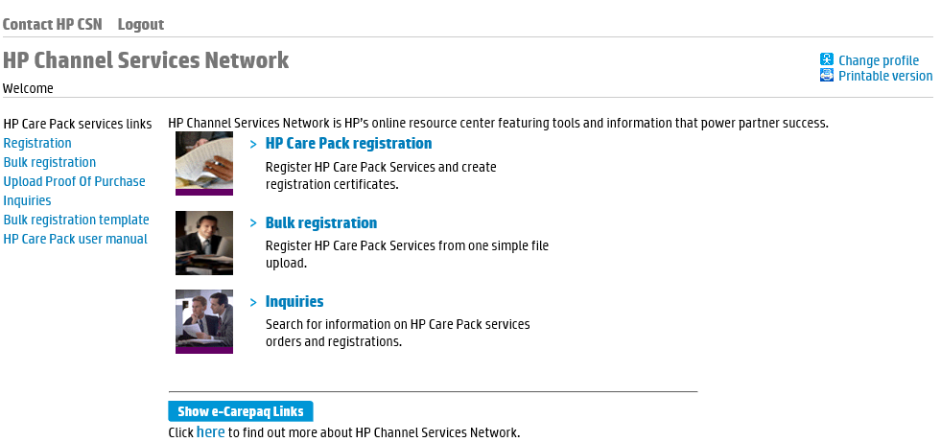**HP CSN Console Page – Reseller Menu View**

Standard Navigation Bar on All HP Care Pack Services Tool Pages

Menu Options for Resellers

# Section 5 - HP Care Pack Service Registration

Congratulations on your recent HP Care Pack service purchase. The next step is to register the HP Care Pack service, so your customer can begin enjoying all the benefits.

#### Bold Data Entry Fields

Throughout the HP Care Pack services tool, you will notice that some data entry fields are bold, while others are not. Bold fields are required for processing. Please complete all bold fields as applicable.

* **Step 1** - From the HP Care Pack services tool home page, choose the “registration” option

from the menu page.

At this point, the Registration page appears.

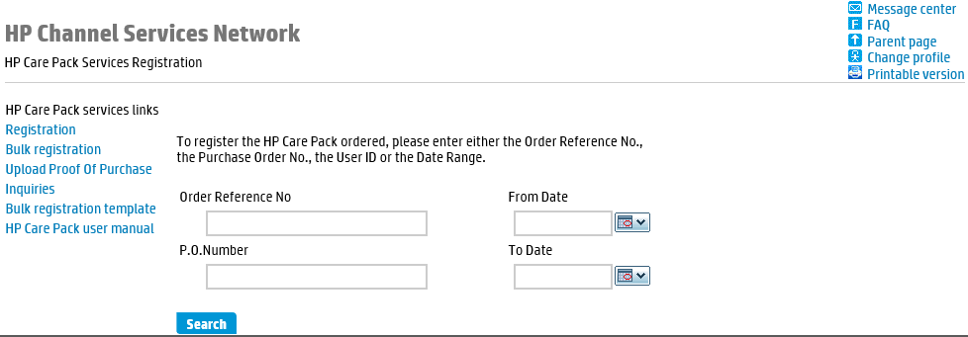**HP Care Pack Services Registration Screen**

* **Step 2** - To register the HP Care Pack service ordered, please enter at least one of the

following:

* Order Reference Number

*Note:* The order reference number is the reference number provided at the end of an on-line order. (Example: EMS00000123) Use the P.O. number query function to retrieve orders that were not placed through this on-line tool.

* P.O. Number
* Date Range (From Date – To Date)
* **Step 3** - Click on the “search” button.

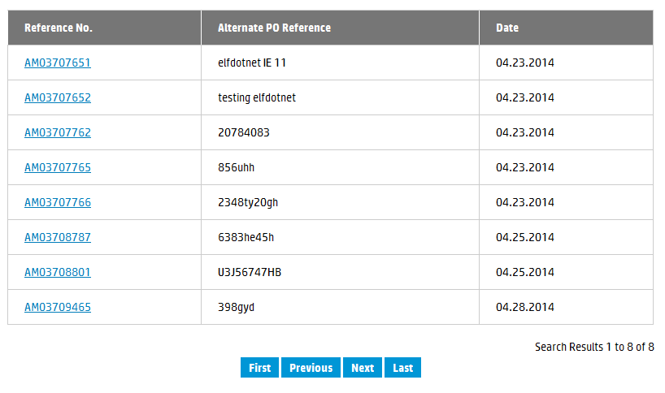At this point, a list of HP Care Pack services ordered appears.

**HP Care Pack Services Registration – Order List**

* **Step 4** - Locate the appropriate order and click on the hyper-linked reference number.

*Note:* At this point, Order Information and Registration Information tabs appear. The Order Information tab is the default.

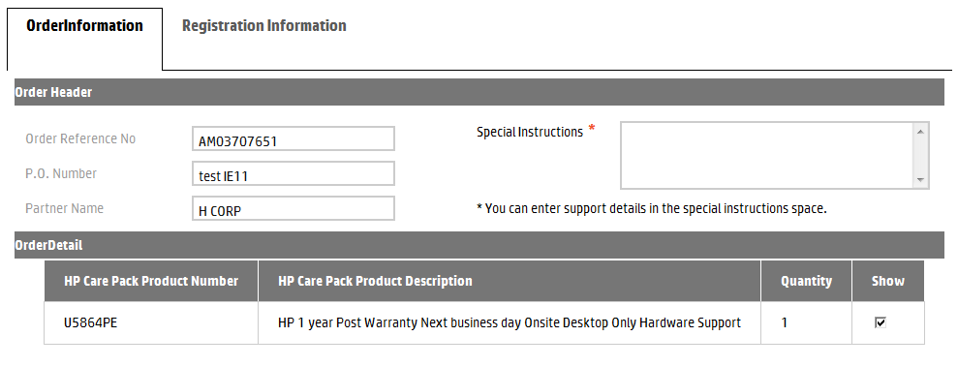**Order Information Tab**

* **Step 5** - Review the Order Header and Order Detail information carefully, to ensure you are registering the correct HP Care Pack service.

*Notes: -* The “Show” check box under the Order Detail section of the page is check marked by default. This will show the line items visible for configuring the hardware to the service if this order contained hardware products.

- The configure feature allows you to link an HP Care Pack service to a hardware product, if applicable. The configure feature is not available if the order does not contain hardware.

* **Step 6** - Enter any applicable support details in the Special Instructions section.

*Important note:*  When services and hardware are sold together on the same order, HP CSN allows you to configure the hardware to the appropriate service. Steps 7a and 7b are not applicable when the order does not contain hardware.

* **Step 7a** - Under the Configuration Section, select the appropriate HP Care Pack service from the HP Care Pack Services Parts List drop down menu.

*Note:* The Configure Section of the screen will not appear if the order does not contain hardware.

* **Step 7b** - Check the appropriate parts under the Hardware Parts List to link with the HP Care Pack service selected in Step 7a.
* **Step 8** - Click on the Registration Information tab.

At this point, Registration Information page appears.

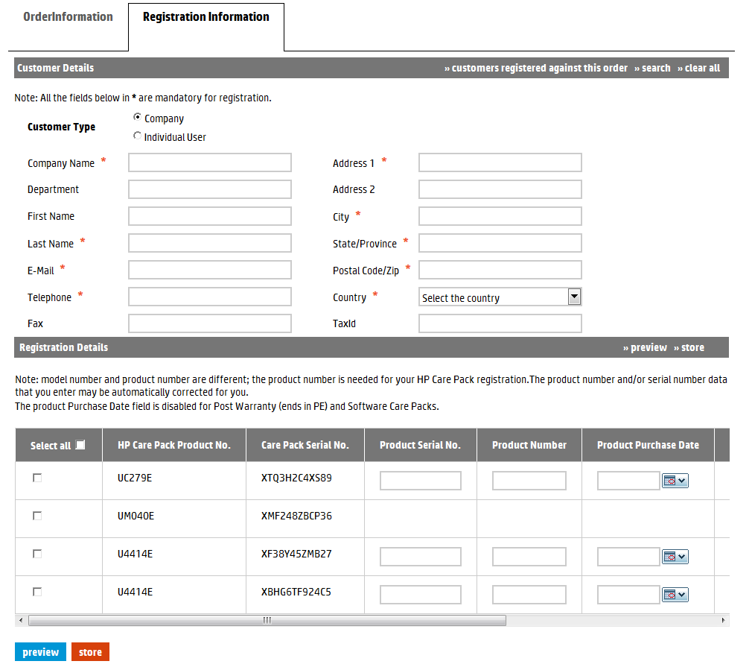**Registration Information Tab – Customer and Registration Details (displayed using two images)**

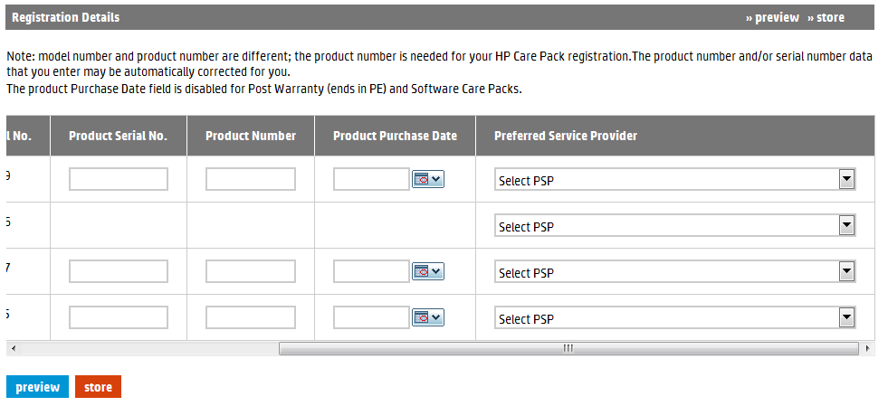**Registration Information Tab – Product Registration Details (continued)**

Notice the scroll bar that allows you to view all the fields for each product

* **Step 9** - Enter the Customer Details.

*Notes:*  - Customer Details represent the company name, address and contact information of the customer which will interact with HP to receive support. This is where the equipment is located.

- The “>>search” option allows you to automatically populate the Customer Information fields by entering search criteria in one or more of the required fields. If a match for the information is not found, the system will alert you.

- Initially, the customer list holds no data, but each time you enter new Customer Information the system saves the data for future use.

* **Step 10** - Under Registration Details, check the box for the HP Care Pack service you want to register. Alternatively, you can check the box directly under “Select all” to

register all HP Care Pack services listed.

*Note:* Click on the “store” button to save the Customer Details and Registration Details, in order to complete the registration later.

* **Step 11** -Enter the Product Serial Number and Product Number for each HP Care Pack service ordered.

*Notes: -* Notice the + sign to the right of the HP Care Pack Services Serial Numbers. Based on hardware information availability, + sign will display the product serial number and product number as hyperlinks. Click on the appropriate link to automatically populate the Product Serial Number and Product Number text boxes.

- The Configure Section and associated + sign are not available if the order does not contain hardware.

- A hardware product number is not necessary when the unit has a 12-digit serial number.

* **Step 12** - If required, enter the Product Purchase Date. This represents the date the customer purchased the hardware that is to be supported by this HP Care Pack.

*Notes:*  - The product purchase date cannot be more than 90 days from the HP recorded product purchase date. If the date entered is more than 90 days from the HP recorded product purchase date, you would need to upload a Hardware Proof of Purchase. A warning message to this effect will appear on the screen.

- This Product Purchase Date field will be available for In-warranty HP Care Pack. It will not be available for software only or post-warranty HP Care Packs.

* **Step 13** - Select a Preferred Service Provider for each HP Care Pack service ordered.

**Registration Information Screen Selection Fields**

|  |  |  |  |  |
| --- | --- | --- | --- | --- |
| Field | Type | | | Definition |
| Customer Details | | | | |
| >>search | List button | | | The “>>search” option allows you to automatically populate the Customer Information fields by entering search criteria in one or more of the required fields. If a match for the information is not found, the system will alert you.  Initially, the customer list holds no data, but each time you enter new Customer Information the system saves the data for future use. |
| >>clear all | Clear button | | | Click this button to clear all data entered under Customer Information. |
| Customer Type | Button | | | Select the company or individual for customer type.  **Note**: Bold fields must be completed to execute the order. The required fields may be different depending on the customer type you choose. |
| Company Name | Text field | | | Enter the company name.  **Note**: Required field for customer type: company. |
| Department | Text field | | | Enter the appropriate department. |
| First Name | Text field | | | Enter the first name of the contact person  **Note**: Required field for both customer types: company and individual. |
| Last Name | Text field | | | Enter the last name of the contact person.  **Note**: Required field for both customer types: company and individual. |
| Email | Text field | | | Enter the email address for the contact person.  Note: Required field for customer type: company. |
| Telephone | Text field | | | Enter the telephone number for the contact person.  **Note**: Required field for both customer types: company and individual. |
| Fax | Text field | | | Enter the fax number for the contact person. |
| Address 1 | Text field | | | Enter the address. |
| Address 2 | Text field | | | Enter the address. |
| City | Text field | | | Enter the city. |
| State/province | | Text field | | Enter the state or province. |
| Postal Code/zip | Text field | | | Enter the postal or zip code. |
| Country | Drop down menu | | | Select the appropriate country. |
| TaxId | Text field | | | Enter the customer tax identification.  **Note:** Only required for Russia. |
| Registration Details | | |  |  |
| preview | Button | | | Once all registration information is entered, click this button to view the registration information. |
| store | List button | | | Click this button to save the Customer Details and Registration Details, in order to complete the registration at a later time. |
| Select all | Check box | | | Check the box next to the HP Care Pack service you want to register.  **Note:** To select all HP Care Pack services, check the box directly under “Select all”. |
| HP Care Pack Service Product No. | Text field | | | This field automatically populates. |
| Care Pack Serial No. | Text field | | | This field automatically populates. |
| Product Number | Text field | | | Enter the product number.  Note: A hardware product number is not necessary when the unit has a 12-digit serial number. |
| Product Purchase Date | Date selection | | | Enter or select the Product Purchase Date.  Note: If you do not enter a date, the default is the HP recorded product purchase date. |
| Preferred Service Provider | Drop down menu | | | Select a Preferred Service Provider for each HP Care Pack service ordered.  Note: If you do not choose a PSP, the default is HP. This field is not accessible and grayed out if the option is not available to you. |
| Product Number | Text field | | | Enter the product number.  Note: A hardware product number is not necessary when the unit has a 12-digit serial number. |
| Product Purchase Date | Date selection | | | Enter or select the Product Purchase Date. |

* **Step 14** - Click on the “preview” button to view the registration information.

At this point, the Preview Registration page appears.

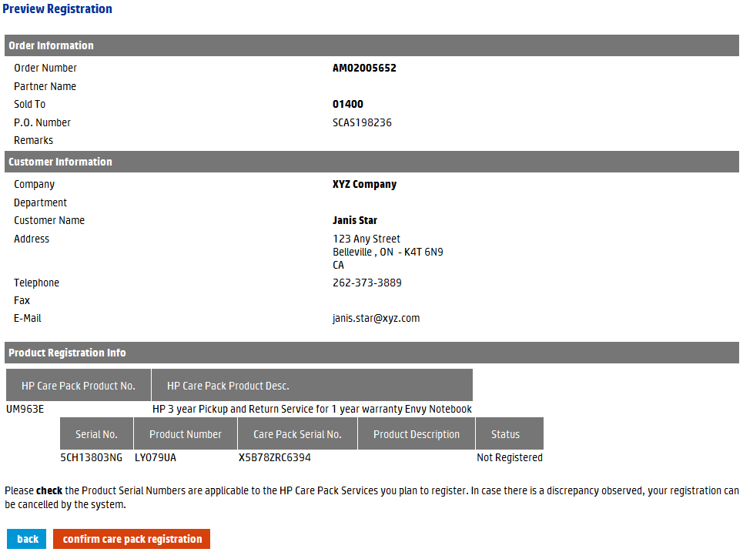**Preview Registration Screen**

**Notice the status is “Not Registered” at the preview step.**

* **Step 15 -** Review the registration information carefully. If all of the information is accurate, click on the “confirm care pack registration” button to complete the registration.

At this point, the message “Care Pack(s) Registered” appears at the top of the page.

*Note:* To change Customer Details or Registration Details, click on the “back” button.

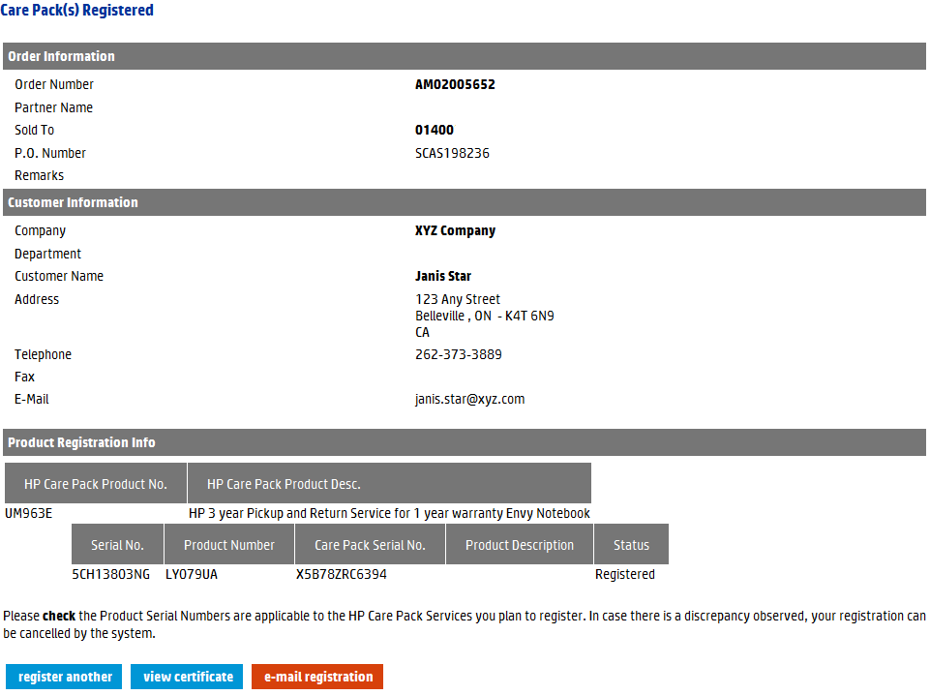**HP Care Pack Services Registration Screen**

**Notice the status is “Registered” at the registered step.**

* **Step 16** - To register another HP Care Pack service, click on the “register another” button. To forward an email with a link to print the certificate, click on the “e-mail registration” button. To print the HP Care Pack service registration certificate, click on the “view certificate” button.

At this point, printing options for the HP Care Pack service registration certificate appear.

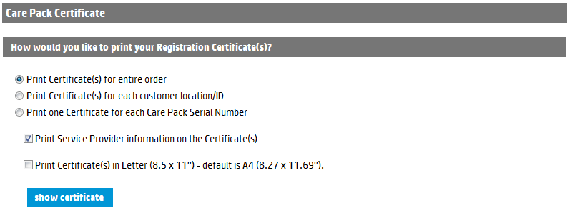**Printing Options for HP Care Pack Service Registration Certificate**

*Notes:* - The Print Service Provider Information on the Certificate(s) option only applies if you chose a Preferred Service Provider at the time of registration.

- The assignment of a Preferred Service Provider is not an option available to all users. This option must be enabled in the user’s profile. For more information, please contact your company’s HP CSN administrator.

*Notes:* - The Print Service Provider Information on the Certificate(s) option only applies if you chose a Preferred Service Provider at the time of registration.

- The assignment of a Preferred Service Provider is not an option available to all users. This option must be enabled in the user’s profile. For more information, please contact your company’s HP CSN administrator.

* **Step 17**- Choose the preferred printing options and HP Care Pack service information.
* **Step 18**- Click on the “show certificate” button.

At this point, the HP Care Pack service registration certificate appears.

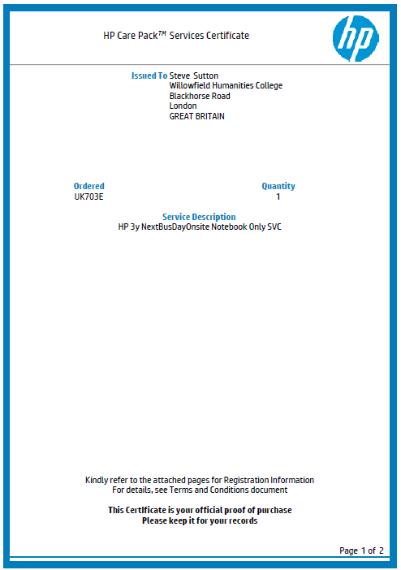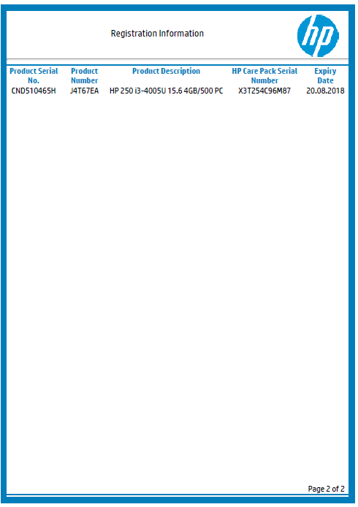**HP Care Pack Service Registration Certificate**

*Notes:* - Each certificate includes information about the customer, the hardware product, the service, and the Preferred Service Provider, if selected.

- To print the certificate, use your browser print option.

# Section 6 – Bulk registration

## Bulk registration

This functionality allows you to register several HP Care Pack services at once, saving you valuable time and resources. This form is for registering HP Care Pack services that have already been ordered, but not yet registered. It is especially helpful if you need to register large volumes of HP Care Pack services.

**Bold Data Entry Fields**

Throughout the HP Care Pack services tool, you will notice that some data entry fields are bold, while others are not. Bold fields are required for processing. Please complete all bold fields as applicable.

**Bulk Registration Template Guidelines**

After you upload the completed template, you will receive an email confirming the bulk uploads, as well as details regarding status of your bulk uploads. The file will state, by line item, if any line items were not successfully processed and why. In this case, correct any items and upload only those corrected line items for reprocessing. **DO NOT UPLOAD THE ENTIRE FILE AGAIN!**

* **Step 1** - From the HP Care Pack services tool home page, choose the “Bulk registration template” option from the left navigation bar and complete, at minimum, the required information fields.
* **Step 2** - Enter, at least, the required information fields.

*Note:* - Bulk templates are universal for all regions. However, some fields might be mandatory in one region, but not in another. See the “How to Use This Template” tab within the template for more information.

- An example of the Bulk Registration template is on the next page.

**Bulk Registration Template (displayed using two images)**

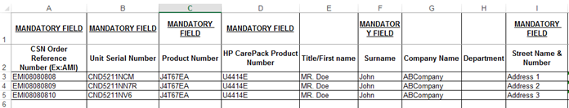

**Bulk Registration Template (continued)**

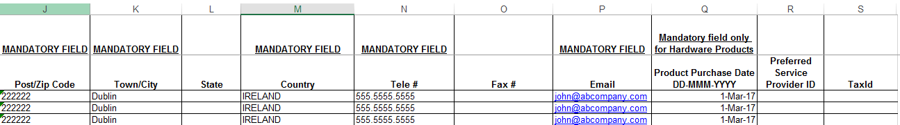

*Important notes:* - Opening two templates at the same time using Internet Explorer will cause a page error. When you open a template or report, it is highly recommended that you save it to your hard drive.

* **Step 3** – Enter the Order Reference number.

*Note:* The order reference number is the reference number provided at the end of an on-line order. (Example: EMS00000123).

If you are unsure of your Order Reference Number, use the inquiries functionality to pull up the order by Date Range and/or P.O. Number and make a note of the associated Order Reference Number.

* **Step 4 –** If required; enter the Product Purchase Date. This represents the date the

customer purchased the hardware that is to be supported by this HP Care Pack.

*Note:* The product purchase date cannot be more than 90 days from the HP recorded product purchase date. If the date entered is more than 90 days from the HP recorded product purchase date, you would need to upload a Hardware Proof of Purchase. A warning message to this effect will appear on the screen.

This Product Purchase Date field will be available for In-warranty HP Care Pack. It will not be available for software only or post-warranty HP Care Packs.

* **Step 5** - If appropriate, enter a Preferred Service Provider (PSP)

*Note:* If you add your company’s PSP ID to some care packs, your company will be recognized as the service provide for all these care packs.

This field is optional. If you do not enter a PSP ID, the default provider is HP.

The ability to choose a PSP is not an option for all users or care packs. This field will be disregarded if the option is not available.

* **Step 6 –** Save the file on the computer.
* **Step 7 -** Return to the Bulk Registration page of HP CSN.
* **Step 8 -** Enter the file name of the Bulk Registration template completed earlier.
* **Step 9** - Choose the “Bulk registration” option from the left navigation bar.

At this point, the Bulk Registration page appears.

**Bulk Registration – File Upload Screen**

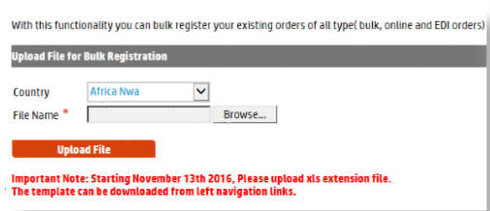

* **Step 10** - Click on the “Browse…” button to retrieve the bulk ordering file saved earlier.
* **Step 11** - Click on the “upload file” button.

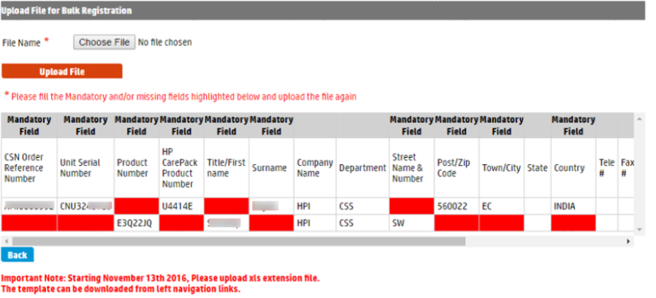If there are missing details, the user will be notified.

*Important note:* You will receive an email confirming the bulk uploads, as well as details regarding status of your bulk uploads. The file will state, by line item, if any line items were not successfully processed and why. In this case, correct any items and upload only those corrected line items for reprocessing. **DO NOT UPLOAD THE ENTIRE FILE AGAIN!**

## Bulk Guidelines

This functionality allows you to register several HP Care Pack services at once, saving you valuable time and resources. It is especially helpful if you need to register large volumes of HP Care Pack services.

New templates are available in excel format.

Opening two templates at the same time using Internet Explorer will cause a page error. When you open a template or report, it is highly recommended that you save it to your hard drive.

Character Limits - COMPANY_NAME 160, FIRST_NAME 30, LAST_NAME 30, ADDRESS1 160, DEPARTMENT NAME OR SUITE NUMBER 20, CITY 50, STATE 40, ZIPCODE 20, PHONE 20, FAX 20, EMAIL_ADDRESS 50, TAXID 20. **Exceeding the limit will cause a registration failure.**

During Bulk registration, process 5000 line items within one file. **Do not exceed the limit**.

Fill the mandatory information in the template and ensure that **no blank spaces are entered** after the Unit serial number, Product number, HP Care Pack Product Number, etc., in the template.

Product Purchase Date should be updated in the format DD-MMM-YYYY whenever applicable. **Other formats will cause file invalid and registration failure.**

After you upload the complete template, you will receive an email confirming the bulk uploads, as well as details regarding status of your bulk uploads within 2 to 3 hours of uploading the file.

The file will state, by line item, if any line items were not successfully processed and why. In this case, correct any items and upload only those corrected line items for reprocessing. **Do not upload the entire file again**.

User have the possibility to check the upload status on a tracking page (ELFI) under “Get Bulk Upload status report”

## Bulk Error Messages

| **Error Code** | **Error Messages** | **Explanation** |
| --- | --- | --- |
| REG017 | The supplied Fixed Care Pack cannot be registered without an end-customer email address | This error is due to Missing End customer email address |
| REG022 | The supplied Product Number ''{0}'' is not recognized. | This error is due to Invalid Product Number provided during bulk registration |
| REG024 | The supplied Product Number ''{0}'' is not compatible with the supplied Fixed Care Pack | This error is due to wrong Fixed Care Pack for the available HW |
| REG030 | Unable to accept this registration because the Hardware Product Number cannot be validated against the Warranty Systems | This error is due to Invalid Serial Number provided during bulk registration |
| REG033 | This Fixed Care Pack has previously been deactivated and is no longer usable or available for registration | This error is due to Serial Number already canceled in the system |
| REG041 | The supplied Hardware product details cannot be validated due to Weak Warranty. To complete HP Care Pack registration, please contact HP and provide Hardware Proof of Purchase | This error is due to Invalid Product Number provided during bulk registration |

## Proof of Purchase Upload

In order for your customers to benefit of the proper Care Pack support period, the product purchase date (PPD) needs to updated and in some cases, a proof of purchase (POP) is required for validation.

HP Channel Services Network (CSN) Care Pack tool will notify the users when it is required to upload POP. You will have the possibility to directly upload the POP document using the available link on the left navigation under HP Care Pack services links. Similar access will be available for our resellers.

End customers will also be able to upload the proof of product purchase using the registration link.

* **Step 1** – From the HP Care Pack services tool home page, choose the “Upload Proof Of

Purchase” option from the left navigation bar or type **ELPP** speedcode

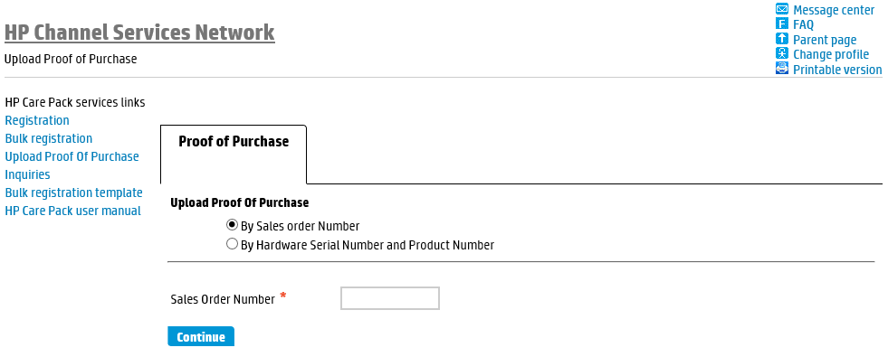

* **Step 2 –** Select either by *Sales order Number* or by *Hardware Serial Number and Product*

*Number*

*Important note:* The submission of the proof of purchase document(s) is needed for Care Pack registration validation

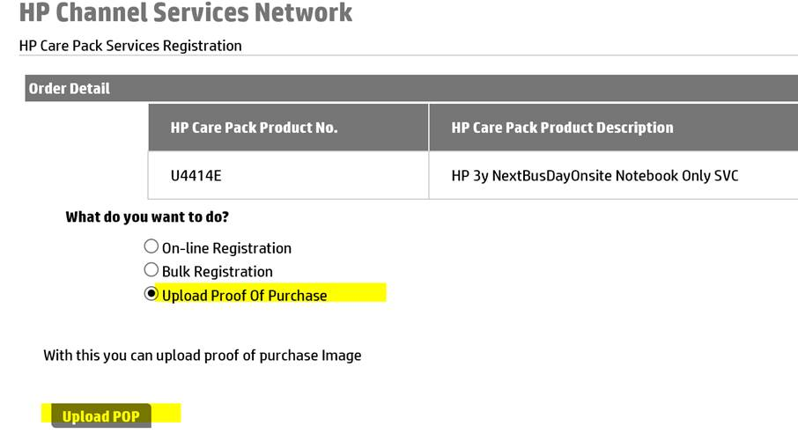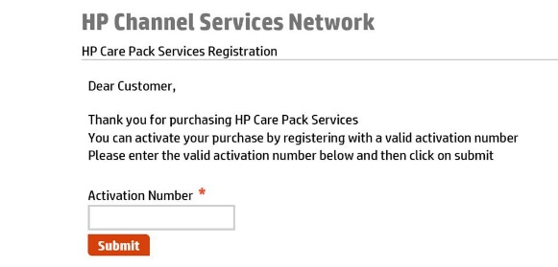End customers will also be able to upload the proof of product purchase using the registration link.

# Section 7 - Update Registration

This functionality allows you to update the customer information for any registered HP Care Pack service. Should the customer move locations, or even move the registered hardware to a different location, it is critical that you update the customer information so they receive the proper service.

* **Step 1** - From the HP Care Pack services tool home page, choose the “Update Registration” option from the left navigation bar.

At this point, the Registration search page appears. Different search fields appear, depending on the search option you choose.

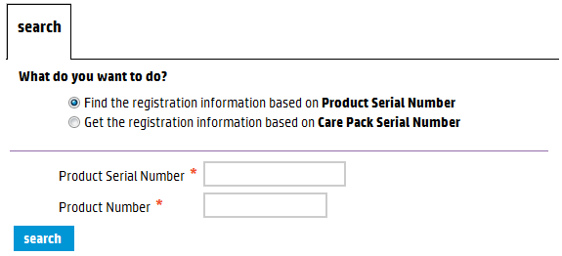**Update Registration Screen – Search by Serial Number (with Product Number)**

**Update Registration Screen – Search by HP Care Pack Serial Number**

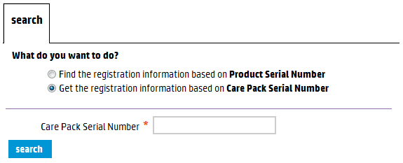

* **Step 2** - To search for the proper HP Care Pack service registration information, enter the hardware serial number (with product number) or the HP Care Pack service serial number.

*Note:* To update the registration, you must first search for the proper HP Care Pack service. You can search by hardware serial number (with product number) or by the HP Care Pack service serial number. Different data entry search fields appear, depending on the search option you choose.

* **Step 3** - Click on the “search” button.

At this point, the Customer Detail, Registration Detail, and the Order Detail for that HP Care Pack service appear. You cannot update or modify the information in the Registration Detail or Order Detail sections.

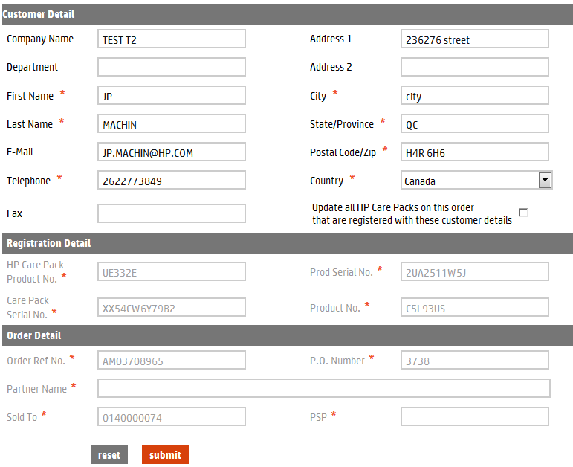**Update Registration – Customer Detail Screen**

*Note:*  Information about hardware cannot be modified at the user level. For example, if an HP Care Pack service is registered to a unit serial number that is turns out to be DOA (Dead on Arrival), the registration information must be updated to reflect the serial number of the replacement unit.

In this instance, contact your Regional HP Care Pack service contact person or support line.

* **Step 4 -** Update the Customer Detail as needed, then click on the “submit” button. Click on the “reset” button, to erase any changes made and restore the original customer information.

Once you submit the changes the message “Registration Updated” appears above the Customer Details section.

*Note:* The reset function cannot be used after the submit function.

# Section 8 – Partner Inquiries

This function allows you to query several different reports for HP Care Pack services. Report options include:

* Get Registration Report in excel format.
* Get Orders Detail Report in excel format.
* Get the sales orders placed within a Date Range and/or by the P.O. Number.
* Perform an inquiry on the Sales Order Number.
* Find the registration information based on Serial Number.
* Get the registration information based on Care Pack Service Serial Number.
* Get Registrations Expiring in a date range report.
* Get Bulk Upload Status report.
* Display Proof of Purchase based on Hardware Serial number and Product number.

*Notes:* - Any inquiry that requires a date range (From Date – To Date) is limited to a maximum 45 days in range.

- It does not matter the date chosen for the query start (From Date), but the range cannot extend more than 45 days from that date.

- The end date (To Date) cannot extend past today’s date.

- The “Get Registration Expiring in a date range report” is limited to a 90 days date range that can be any time in the past or the future. This report will return the results to the email address indicated in the Email ID field.

* **Step 1** - From the HP Care Pack service tool home page, choose the “Inquiries” option from the left navigation bar.

At this point, the Inquiries page appears.

**Partner Inquiries Screen**

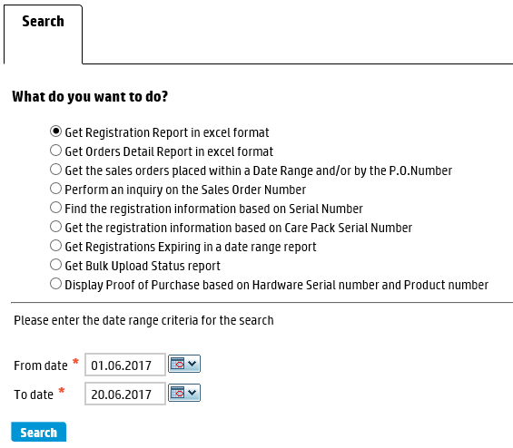

* **Step 2** - Choose the preferred query option and proceed to Step 3 of the appropriate section, depending on the query option chosen.

*Notes: -* To get Registration Report in excel format, proceed to section **8.1.**

- To get Orders Detail Report in excel format, proceed to section **8.2.**

- To get the sales orders placed within a Date Range and/or by the P.O. Number, proceed to section **8.3.**

- To perform an inquiry on the Sales Order Number, proceed to section **8.4.**

- To find the registration information based on Serial Number, proceed to section **8.5.**

- To get the registration information based on Care Pack Service Serial Number, proceed to section **8.6.**

- To get Registrations Expiring in a date range report, proceed to section **8.7.**

- To get Bulk Upload Status report, proceed to section **8.8.**

- To display Proof of Purchase based on Hardware Serial number and Product number, proceed to section **8.9.**

## Get Registration Report in Excel Format

* **Step 3** - Choose the Get Registration Report in Excel format option.

**Partner Inquiries Screen – Registration Report**

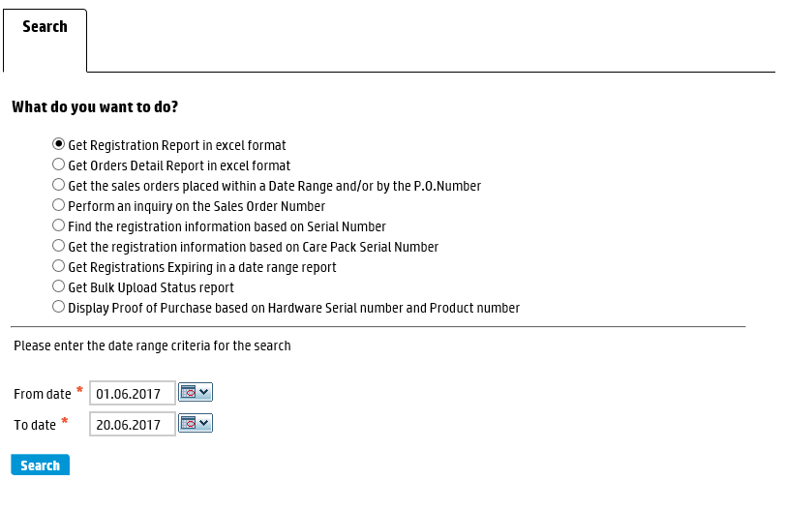

* **Step 4** - Enter or select a start date (From date) and an end date (To date) for the query.
* **Step 5** - Click on the “search” button.

At this point, the Registration Report opens in a separate Excel spreadsheet.

*Notes:*  - You can open or save the spreadsheet.

- Opening two templates at the same time using Internet Explorer will cause a page error. - - When you open a template or report, it is highly recommended that you save it to your hard drive.

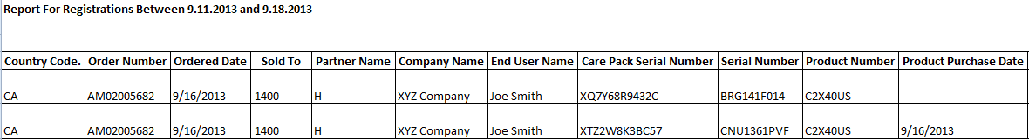**Registration Report in Excel Format (displayed using two images)**

**Registration Report in Excel Format (continued)**



## Get Orders Detail Report in Excel Format

* **Step 3** - Choose the Get Orders Detail Report in Excel format option.

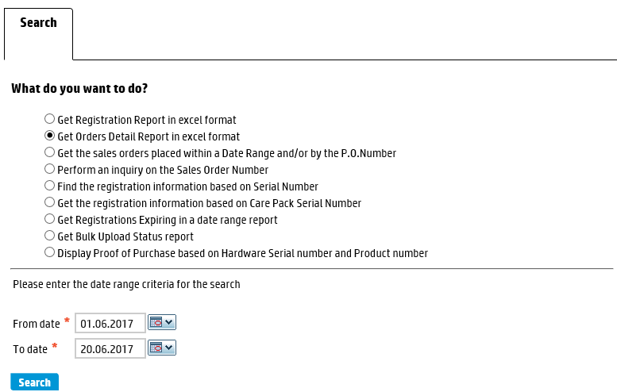**Partner Inquiries Screen – Orders Detail Report**

* **Step 4** - Enter or select a start date (From date) and an end date (To date) for the query.
* **Step 5** - Click on the “search” button.

At this point, the Orders Detail Report opens in a separate Excel spreadsheet.

*Notes:* You can open or save the spreadsheet.

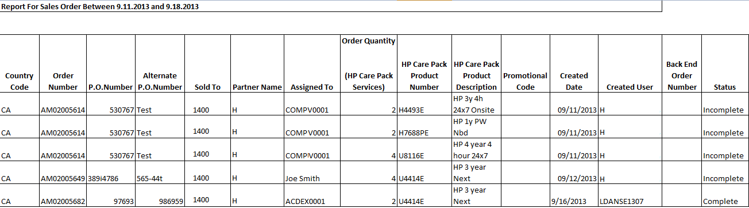**Orders Detail in Excel Format**

*Notes: -* The status column refers to the registration status of the order, not the order itself.

- Opening two templates at the same time using Internet Explorer will cause a page error. When you open a template or report, it is highly recommended that you save it to your hard drive.

## Get the Sales Orders Placed within a Date Range and/or by the P.O. Number

* **Step 3** - Choose the Get the Sales Orders Placed within a Date Range and/or by the P.O. Number option.

**Partner Inquiries Screen – Sales Orders by Date Range and/or P.O. Number**

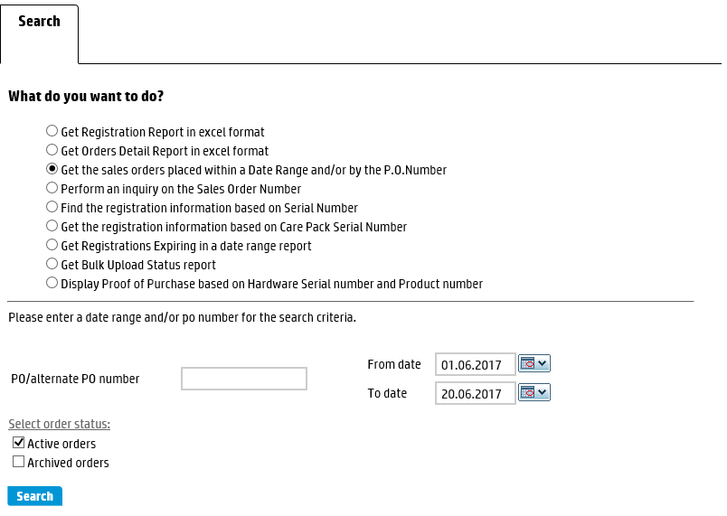

* **Step 4** - Enter the P.O. number or enter or select a start date (From date) and an end date (To date) for the query.

*Note:* The P.O. number can be a Tier 1 P.O. number, a customer P.O. number or a Tier 2 reseller alternate P.O. number.

* **Step 5** - Select Active orders, Archived orders, or both.

*Note:* Once you archive an order, the order is hidden from you for administrative ease, but you can always restore an order to active or search for archived orders, if necessary.

* **Step 6** - Click on the “search” button.

At this point, a list of sales orders appears.

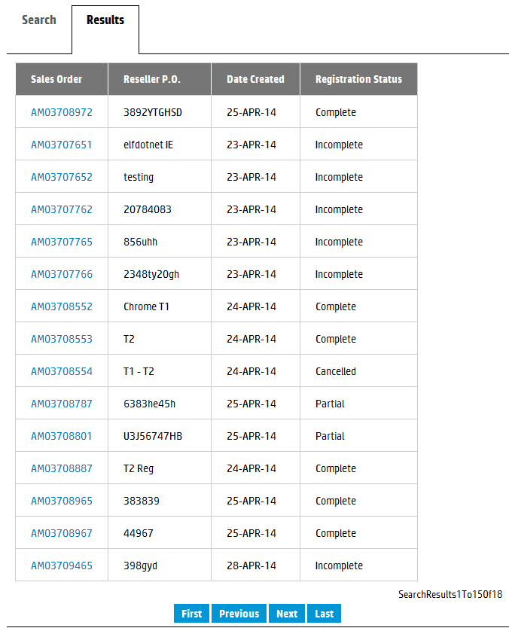**List of Sales Orders by PO and/or Date Range**

**To sort by heading, click on any hyper-linked heading.**

**To view the sales order, click on any hyper-linked sales order number.**

*Note:* To sort the list by heading click on the hyper-linked heading itself.

* **Step 7** - Click on the hyper-linked sales order number to view the details of the order.

At this point, the sales order appears.

*Note:* The sales order number is the reference number provided at the end of an on-line order. (Example: AM02005649).

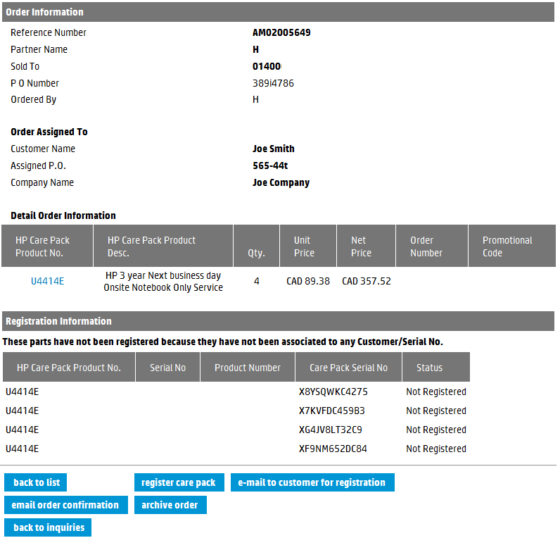**Sales Order Detail Screen**

* **Step 8** - Use the function buttons at the bottom of the page to execute the preferred next

step.

## Perform and Inquiry on the Sales Order Number

* **Step 3** - Choose the Perform an Inquiry on the Sales Order Number option.

**Partner Inquiries Screen – Sales Order Number**

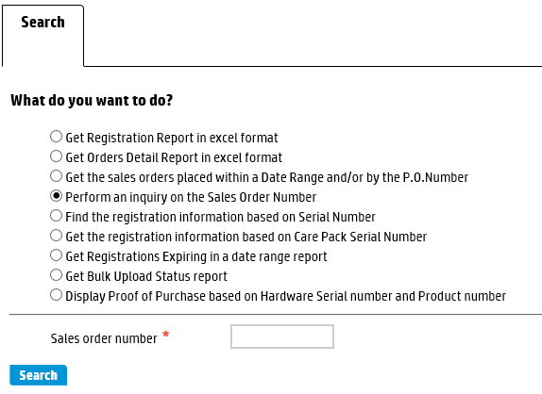

* **Step 4** - Enter the Sales order number.

*Note:* The sales order number is the reference number provided at the end of an on-line order. (Example: AM02005649).

* **Step 5** - Click on the “search” button.

At this point, the Order Information and Registration Information sections appear.

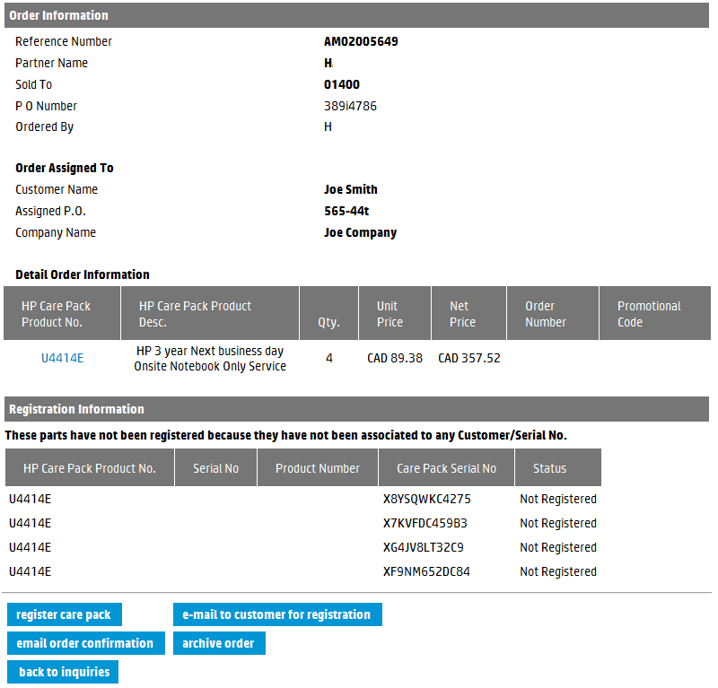**Sales Order Detail Screen**

* **Step 6** - Use the buttons at the bottom of the page to execute the preferred next step.

## Find the Registration Information Based on Serial Number

* **Step 3** - Choose the Find the Registration Information Based on Serial Number option.

**Partner Inquiries Screen – Serial Number**

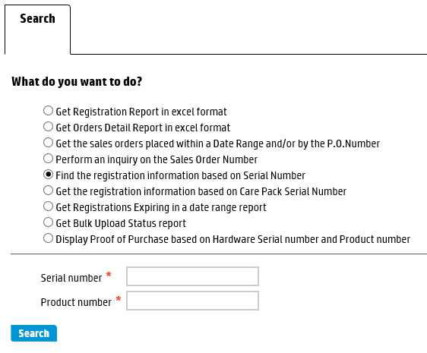

* **Step 4** - Enter the Serial Number and Product Number.

*Note:* You must enter a product number, along with the serial number.

* **Step 5** - Click on the “search” button.

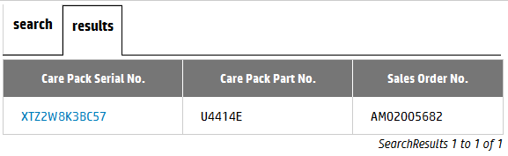At this point, a list of HP Care Pack services registered to this serial number appears.

**Registrations for this Product Serial Number**

* **Step 6** - Click on the hyper-linked Care Pack Serial Number.

At this point, the Registration Information appears.

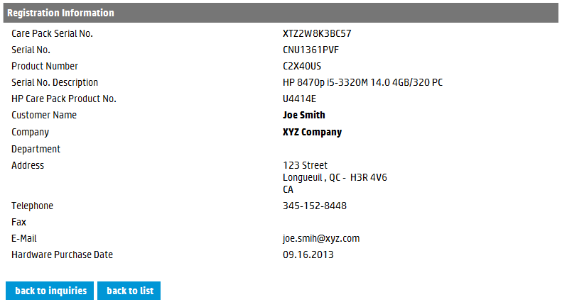**Registration Information Screen**

## Get the Registration Information Based on Care Pack Serial Number

* **Step 3** - Choose the Get the Registration Information Based on Care Pack Serial Number option.

**Partner Inquiries Screen – Care Pack Serial Number**

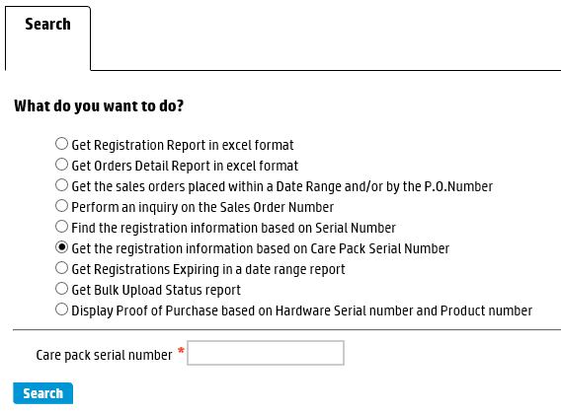

* **Step 4** - Enter the Care Pack Serial Number.
* **Step 5** - Click on the “search” button.

At this point, the Registration Information for that HP Care Pack service appears.

**Registration Information Screen**

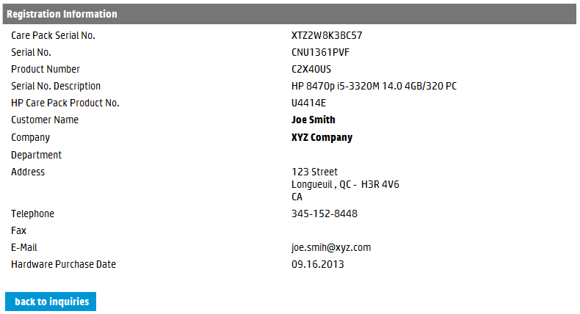

## Get Registrations Expiring in a Date Range Report

* **Step 3** - Choose the Get Registrations Expiring in a date range report option.

**Partner Inquiries Screen – Expiring in Next 90 Days**

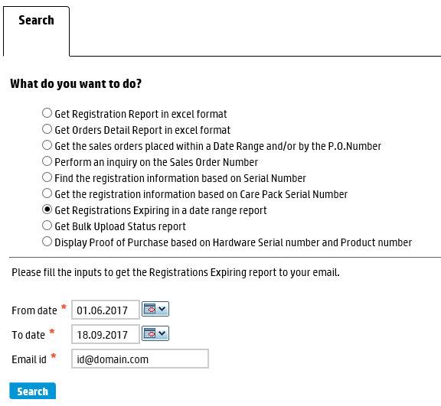

*Notes:*  - The “From” and “To” dates are defaulted to a 90 days period that starts with today’s date. The Email Id is defaulted to the email address associated with the account used for logging in the tool.

- The period cannot be more than 90 days, but can be any period in the future or past.

- The report will be sent to the email id indicated.

* **Step 4** - Change or select different dates as required as well as update the email id if necessary.
* **Step 5** - Click on the “search” button.

At this point, a message appears at the top of the screen to indicate the report will be sent via email.

* **Step 6** - Once the email is received click to open the attachment containing the zipped report.

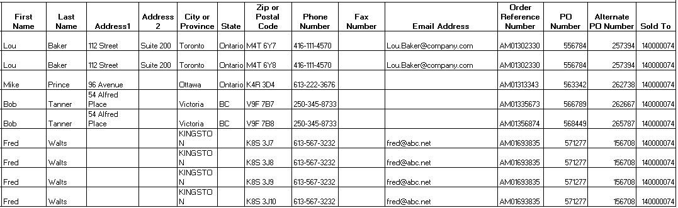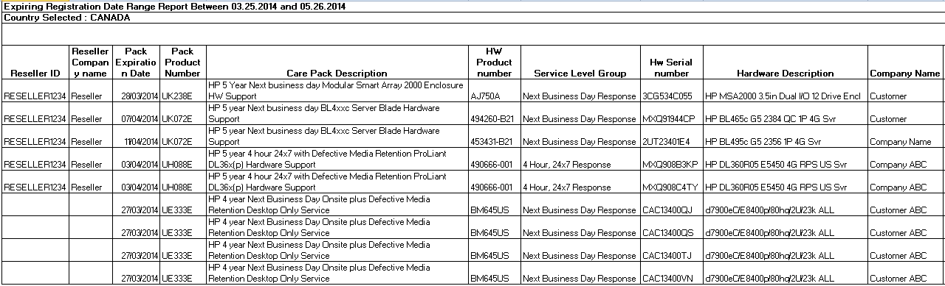**Registration Expiring in Date Range in Excel Format**

## Get Bulk Upload Status report

* **Step 3** - Choose the Get Bulk Upload Status report option.

**Partner Inquiries Screen – Get Bulk Upload Status report**

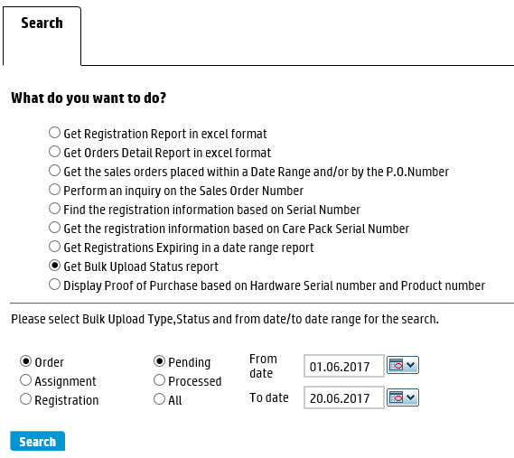

* **Step 4** - Change or select different dates as required as well as select the type of bulk

upload (Order, Assignment, Registration) and the status (Pending, Processed, All)

* **Step 5** - Click on the “search” button.

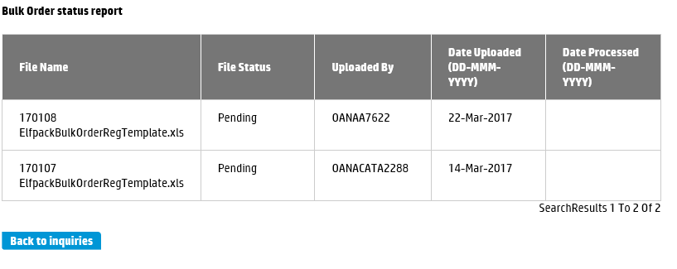At this point, the status of the Bulk files uploaded appears.

## Display Proof of Purchase based on Hardware Serial number and Product number

* **Step 3** - Choose the Display Proof of Purchase based on Hardware Serial number and

Product number option.

**Partner Inquiries Screen – Display Proof of Purchase based on Hardware Serial number and Product number**

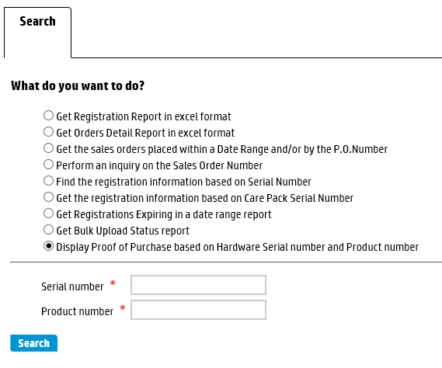

* **Step 4** – Provide the Hardware Serial Number and Product Number
* **Step 5** - Click on the “search” button.

At this point, the uploaded proof of purchase document appears.